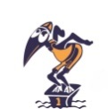
2024 WWSC MERCHANDISE ORDER FORM
If available, items can be collected from the pool once your order has been confirmed.
You will receive an email confirming your items are available and the amount to be paid.
Please see payment details at the end of this form.
All items ordered will need to be paid for via card upon delivery or direct debit prior to delivery. Any items ordered and not collected will be invoiced to the names listed below.
For enquiries and orders please email - waggaswimclubmerchandise@gmail.com
PARENT’S NAME:
SWIMMER’S NAME/S:
CONTACT EMAIL:
CONTACT PHONE: ORDER DATE:
ITEM | INFORMATION/SIZING | QTY | AMOUNT
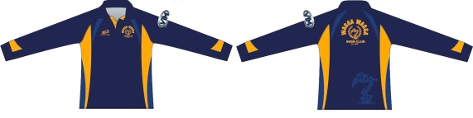  LONG SLEEVE CLUB POLO SHIRT - $47 | MATERIAL: SUBLIMATED POLYESTER  FIT: TRADITIONAL POLO SHIRT WITH CUFFED LONG SLEEVE IN SMALLER/SHORTER CUT - ORDERING UP A SIZE IS RECOMMENDED  COLOUR: DARK BLUE WITH ROYAL BLUE & YELLOW TRIM  SIZE (PLEASE CIRCLE)  KIDS - 12 14  ADULT - XS S M L XL 2XL 3XL 4XL 5XL
SHORT SLEEVE CLUB POLO SHIRT - $45  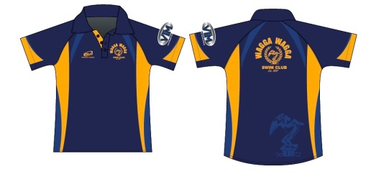 | MATERIAL: SUBLIMATED POLYESTER  STYLE/FIT: TRADITIONAL SHORT SLEEVE POLO SHIRT IN SMALLER/SHORTER CUT - ORDERING UP A SIZE IS RECOMMENDED  COLOUR: DARK BLUE WITH ROYAL BLUE & YELLOW TRIM  SIZE (PLEASE CIRCLE)  KIDS - 8 12 14  ADULT - XS S M L XL 2XL
SHORT SLEEVE CLUB T - SHIRT - $41  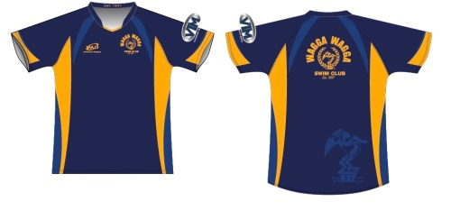 | MATERIAL: SUBLIMATED POLYESTER  STYLE/FIT: SLIM FIT/LONGER LENGTH COLLARLESS SPORT SHIRT  COLOUR: DARK BLUE WITH ROYAL BLUE & YELLOW TRIM  SIZE (PLEASE CIRCLE)  KIDS - 8 10 12 14  ADULT - XS S M L XL 2XL 3XL 4XL
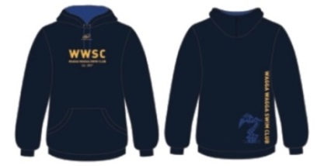  CLUB HOODIE - $62 | MATERIAL: 35% COTTON 65% POLYESTER  FIT: RELAXED/COMFORTABLE FIT HOODIE WITH GENEROUS SLEEVE LENGTH  COLOUR: DARK NAVY BLUE WITH ROYAL BLUE & GOLD TRIM  SIZE (PLEASE CIRCLE)  KIDS - 4 6 8 10 12 14 16  ADULTS - S M L XL

 | ITEM | INFORMATION/SIZING | QTY | AMOUNT
 | TRAINING SINGLETS - $32  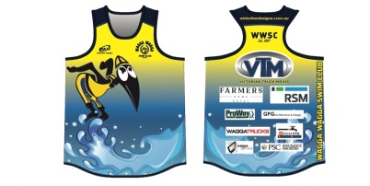 | MATERIAL: SUBLIMATED POLYESTER  FIT: RELAXED FIT - TRUE TO SIZE  COLOUR: MULTI BLUE/YELLOW WITH WAVE  SIZE (PLEASE CIRCLE)  KIDS - 10 12 14  ADULT - XS S M L
 | TRUCKER CAPS - $21  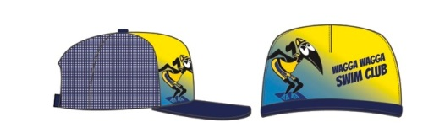 | MATERIAL: 100% POLYESTER  FIT: ADJUSTABLE SNAPBACK  COLOUR: MULTI BLUE/YELLOW  SIZE (PLEASE CIRCLE)  56CM
 | 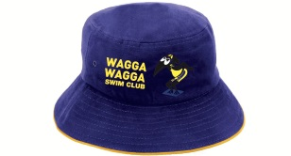  BUCKET HATS - $26 | MATERIAL: 100% COTTON  FIT: LOOSE FIT  COLOUR: ROYAL BLUE WTH GOLD EDGE & YELLOW TRIM  SIZE (PLEASE CIRCLE)  S/M
 | WIDE BRIM HATS - $21  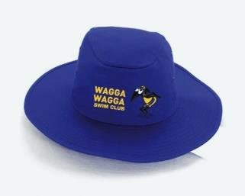  SUN SAFE UPF 50+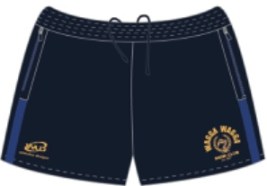 | MATERIAL: POLYESTER/ COTTON  FIT: ADJUSTABLE NECK CORD  COLOUR: ROYAL BLUE WTH YELLOW TRIM  SIZE (PLEASE CIRCLE)  57CM 59CM
 | 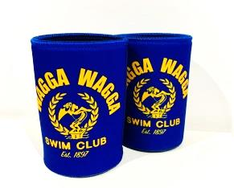  STUBBY HOLDERS - $5 | MATERIAL: NEOPRENE  COLOUR: ROYAL BLUE WTH GOLD TRIM
 | 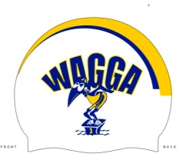  SWIM CAP - $14 | MATERIAL: SILICON  COLOUR: WHITE WITH ROYAL BLUE AND YELLOW TRIM  One size
 | Club shorts - $30 | MATERIAL: SUBLIMATED POLYESTER  FIT: RELAXED FIT - TRUE TO SIZE  COLOUR: BLUE/YELLOW  SIZE (PLEASE CIRCLE)  ADULT - XS S M XL  Limited stock
 | Girls training shorts - $30  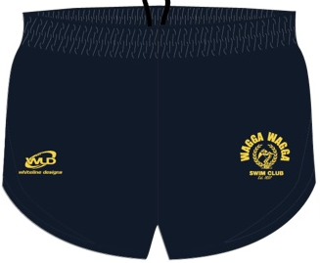 | MATERIAL: SUBLIMATED POLYESTER  FIT: SLIM FIT  COLOUR: BLUE/YELLOW  SIZE (PLEASE CIRCLE)  GIRLS - 10 M L  Limited stock
 | SALE ITEMS  125 Year Club shirt – Last one size XL  $40  125 Year Singlets – 6 LEFT. $30  1x Size 10  2x Size M  3x Size L | MATERIAL: SUBLIMATED POLYESTER  FIT: RELAXED FIT - TRUE TO SIZE  COLOUR: MULTI BLUE/YELLOW WITH WAVE  SIZE (PLEASE CIRCLE)  Shirt. XL  Singlet. 10 M L
TOTAL

Payment details for direct debit:
Acc Name: Wagga Swimming Club Inc
BSB: 325185
Acc No: 38718051
Reference: Please use name as reference

